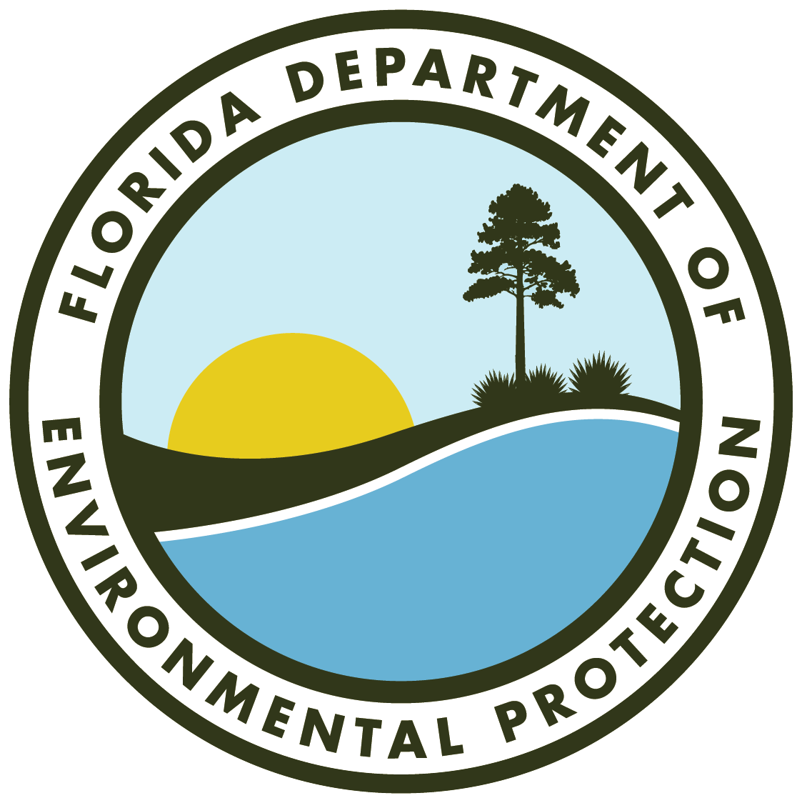

**FLORIDA DEPARTMENT OF ENVIRONMENTAL PROTECTION**

**Biscayne Bay Commission Meeting**

**AGENDA**

**Friday, Jan. 24, 2025 — 10 a.m.**

**Virtual meeting via GoTo Webinar**

(rescheduled from Dec. 12, 2024)

**Join Virtually:** [**GoTo We****binar**](https://attendee.gotowebinar.com/register/8227043422780447318)

**THIS MEETING IS OPEN TO THE PUBLIC**

* Welcome and Introductions.
* Biscayne Bay Watershed Advisory Board Updates.
  + Danielle Cohen-Higgins, Miami-Dade County.
* Reasonable Assurance Plan Update.
  + Pamela Sweeney, Miami-Dade County.
* Strategic Plan and Project Tracker Review.
  + Hampton Hotard, Biscayne Bay Aquatic Preserves.
* Public Comment Period.
* Commission Discussion.
* Closing Remarks.